Design Thinking For Software Engineers
Lab -3
Mobile apps consume excessive data and battery
Name: Selva K Roll No: 24BTCE197
1.Aim of the Experiment
The aim of this experiment is to apply the Design Sprint methodology by following the Empathize, Define, Ideate, Prototype, and Test stages to design a user-centred solution for reducing excessive data usage and battery consumption in mobile applications. The experiment focuses on understanding real user challenges related to app efficiency, background processes, network usage, and power management, and validating proposed solutions through user feedback rather than assumptions.
2.Problem Context
Smartphone users increasingly rely on mobile applications for communication, entertainment, learning, and productivity. However, many apps consume excessive data and battery due to inefficient background processes, constant network requests, poorly optimized media handling, and lack of user-friendly controls for resource management. These issues often result in higher mobile bills, faster battery drain, reduced device performance, and frustration among users. As a consequence, users may uninstall apps, limit usage, or avoid updates, while developers face challenges in retaining engagement and ensuring sustainable app performance.
3.Empathize
Key Observations
• What frustrates users most?
○ Users became frustrated with rapid battery drain, unexpected spikes in mobile data usage, frequent charging needs, and apps running background processes without clear notification.
• Where do users hesitate or seek help?
○ Users hesitated when monitoring data usage, managing app permissions, or identifying which apps were consuming resources. Many sought help when monthly bills increased or when devices overheated during prolonged use.
• What makes users feel confident or unsafe?
○ Clear usage statistics, efficient app performance, battery-saving modes, and transparent background activity increased user confidence. Lack of control, hidden processes, and sudden data consumption made users feel unsafe, leading to reduced trust and eventual app uninstallation.
Activities Performed
• Reviewed interview notes and empathy maps created for students, professionals, and everyday smartphone users experiencing excessive data and battery consumption in mobile apps.
• Observed users navigating commonly used mobile applications while streaming content, browsing social media, and running background services.
• Noted hesitation points such as confusion in identifying which apps consume the most resources, difficulty managing app permissions, and frustration with sudden data spikes or rapid battery drain.
• Recorded emotional responses including anxiety over high mobile bills, irritation with frequent charging, stress during travel when battery runs out, and loss of trust in apps that consume resources without transparency.
Empathy Map
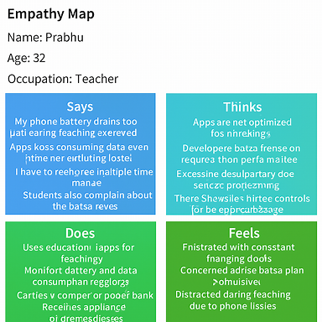
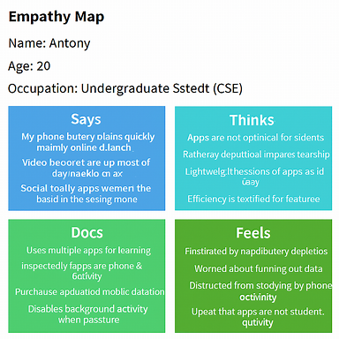
User Insights
- Users uninstall or avoid apps when they consume excessive battery and data without clear explanation.
- Users lose trust quickly when apps run heavy background processes or drain resources unexpectedly.
- Students and professionals feel discouraged when their devices overheat or shut down during important tasks.
- Users lose confidence in apps when monthly bills rise due to hidden data usage.
- Many reduce usage or switch to alternatives when apps lack transparent controls for managing battery and data consumption.
- Visual polish raises expectations, but poor optimization and hidden resource usage drive frustration and abandonment.
4.Define Stage
• Objective
○ To clearly define the core problem faced by mobile app users based on insights gathered from interviews, observations, and empathy mapping.
• Problem Statement
○ Users need a way to efficiently use mobile applications without experiencing excessive data consumption and rapid battery drain because hidden background processes, poor optimization, and lack of transparent controls cause frustration, higher costs, and reduced trust in apps.
• How Might We (HMW) Question
○ How might we design mobile applications that minimize data usage and battery consumption while maintaining performance and user satisfaction, so users can rely on apps without anxiety over costs or device limitations?
5.Ideat
Brainstormed Ideas
- Optimized background process management with user-controlled permissions and notifications for hidden resource usage.
- Data-saving modes including compressed media streaming, reduced auto-sync frequency, and intelligent caching.
- Battery-efficient design through lightweight UI, adaptive refresh rates, and reduced sensor activity.
- Transparent usage dashboards showing real-time battery and data consumption per app feature.
- Smart alerts and recommendations that guide users to close or restrict apps consuming excessive resources.
Idea Selection
A mobile application framework that combines optimized background management, transparent usage dashboards, and intelligent data-saving modes to minimize battery drain and data consumption while maintaining smooth performance and user satisfaction.
6.Prototype Stage
Objective
The objective of this prototype is to create a low-fidelity representation of a mobile application monitoring and optimization system that demonstrates how users can track real-time data usage and battery consumption across installed applications. The prototype illustrates how users can identify high-consuming apps, receive intelligent alerts, and access simple optimization recommendations to reduce unnecessary resource usage.
The prototype aims to evaluate whether these features improve user awareness, minimize rapid battery drain, lower mobile data costs, and enhance overall device performance. It also supports developers and researchers in analyzing application efficiency and identifying opportunities for improving resource management and user experience.
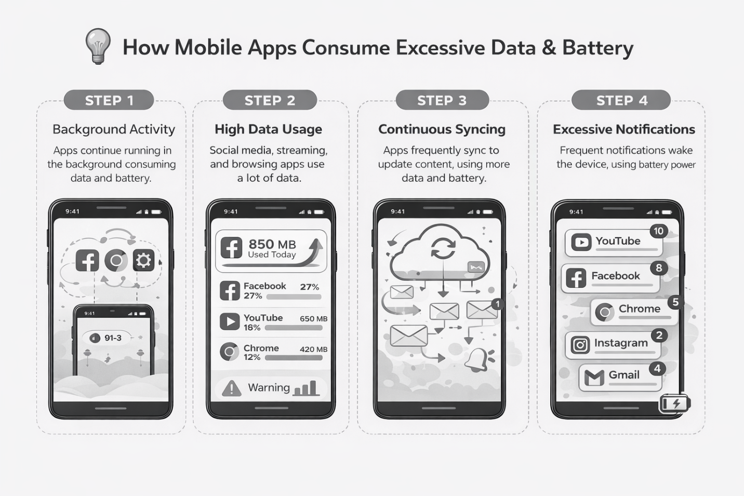
Prototype Description
A personalized home dashboard displaying real-time battery percentage, daily data usage, and top resource-consuming applications
• App usage screen featuring app-wise battery and data breakdown with color-coded indicators (High, Medium, Normal usage levels)
• Smart alerts screen notifying users when an application exceeds predefined data or battery consumption limits
• Optimization panel with one-click “Optimize Now” option and background activity restriction suggestions
• Weekly and daily usage analytics screen showing graphical reports, usage trends, and comparison charts
• Settings page allowing users to customize usage thresholds, enable notifications, and activate battery saver recommendations
Design Rationale
• Real-time monitoring increases user awareness and prevents unexpected battery drain
• Color-coded indicators help users quickly identify high-consuming apps without technical complexity
• Smart alerts reduce hidden background data usage and unnecessary power consumption
• One-click optimization simplifies device management for non-technical users
• Usage analytics encourage informed decision-making and responsible app usage
• Customizable thresholds allow personalized control based on user preferences and data plans
Prototype Type
Low-fidelity wireframes and color UI mockups created to visualize user flows, app interaction screens, and system structure rather than focusing on full technical implementation. The prototype emphasizes usability, monitoring clarity, alert mechanisms, and optimization workflows to test user awareness and control over mobile data and battery consumption.
7.Test stage
Objective
To test the mobile usage monitoring and optimization prototype with selected smartphone users and gather feedback on real-time tracking features, alert effectiveness, usability, and optimization suggestions for reducing excessive data and battery consumption.
Testing Method
• The prototype UI mockups were shown to three smartphone users
• Each user explored the dashboard, app usage screen, alert system, and optimization panel
• Users were asked to identify high-consuming apps using the interface
• Participants were asked to comment on clarity, ease of understanding, usefulness of alerts, and confidence in managing app consumption
• Observations regarding user behavior, confusion points, and interaction patterns were recorded
• Feedback was documented for further refinement and iteration
User Feedback Summary
User 1
Name: Prabhu
Age: 27
Occupation: Teacher
• What Worked Well
○ Real-time dashboard clearly showed battery percentage and daily data usage
○ App-wise ranking helped identify high-consuming applications quickly
○ Color-coded usage indicators were easy to understand
○ “Optimize Now” button made management simple and convenient
○ Smart alert feature increased awareness about background data usage
• What Was Confusing
○ Wanted slightly more explanation about how optimization suggestions work
• User Suggestions
○ Add automatic background app restriction feature
○ Include weekly usage comparison reports
• Observation
○ Prabhu appeared confident while navigating the prototype and appreciated the clarity of the monitoring system. He expressed that such an application would be useful for managing both personal and professional device usage.
User 2
Name: Alfred Antony
Age: 19
Occupation: Student
• What Worked Well
○ Dashboard layout was simple and visually attractive
○ Alerts helped understand which apps were consuming excessive data
○ App usage breakdown made it easy to monitor social media consumption
○ Optimization suggestions felt practical and useful
• What Was Confusing
○ Initially unsure how usage thresholds were set
• User Suggestions
○ Add dark mode option
○ Include daily data usage limit reminder notifications
• Observation
○ Alfred appeared interested and engaged while exploring the prototype. He mentioned that the app would help him control data usage and extend battery life during college hours.
8.Iteration and Improvements
• Improve icon labeling and add short tooltips explaining battery and data metrics
• Allow users to customize data and battery usage thresholds
• Introduce automatic background restriction suggestions for high-consuming apps
• Add weekly and monthly graphical usage comparison reports
• Provide dark mode and personalization settings for better usability
• Include educational tips explaining how apps consume battery and mobile data
9. Reflection
This experiment reinforced the importance of user-centered design in mobile application development. Initial assumptions focused mainly on technical monitoring features, but user feedback revealed deeper concerns such as lack of clarity, confusion about system statistics, and limited understanding of background app activity.
Observing users interact with the prototype highlighted the need for simplified visual indicators, clear alerts, and actionable recommendations rather than just raw usage data. Small interface improvements such as color coding, optimization suggestions, and clear usage breakdown significantly increased user confidence and sense of control.
The Design Sprint approach demonstrated that transparency, simplicity, and usability are critical factors in helping users manage excessive data and battery consumption effectively.
10. Conclusion
The Design Sprint process enabled the identification of genuine user frustrations related to excessive mobile app data and battery consumption and supported rapid validation of a practical solution. Through the Empathize, Define, Ideate, Prototype, and Test stages, a user-centered monitoring and optimization application was conceptualized.
The results indicate that providing real-time visibility, smart alerts, and simple optimization tools can significantly enhance user awareness, reduce unnecessary resource usage, and improve overall device performance. Continuous user feedback remains essential for refining such systems and ensuring long-term usability and effectiveness.

Bottom of Form

